Chapter 17

A Boatload of Metrics

This chapter offers some guidelines for metrics to use in your organization. It presents some metrics that are commonly collected in organizations, some tips on how to devise metrics, and some advice on structuring your metrics process.
We could not possibly discuss everything necessary to set up and administer a top-notch metrics program in one small chapter. To that end, we have listed several books on the subject at the end of this chapter.
For a discussion on the importance of collecting consistent data, and when and how to collect that data, please read Chapter 18, “Statistical Process Control,” and Chapter 19, “A High Maturity Perspective.” By the way, you will find that we use the terms measurement and metric interchangeably. We are sorry if this offends you, but we decided that we really don’t want to weigh in on the war of words around measurement.

Background

When beginning a process improvement effort in an organization, invariably a project manager (PM) or the executive in charge will pull one of us aside and ask, “What metrics should we collect?” We hate that question. We hate it because it shows that the person asking has no clue about what process improvement is and generally only wants a quick fix for his organization. “Just tell us what to collect, we’ll do it, and then we’re done.” We don’t think so. Now, true, this judgment is harsh—after all, these people are only beginning the process improvement journey.
However, one of the first deliverables requested by management from us for any organization is a list of metrics to collect. The managers then mull over the metrics and decide not to collect them anyway because by collecting the metrics, we can really track and report on what is going on in the projects, and, heaven knows, we just can’t have that! So, much moaning and groaning takes place—we don’t have the people to do this, we don’t collect these numbers, we don’t need these numbers, the staff won’t stand for it, and so on. And then, after discussing the pros and cons of each metric, we begin with a very small list. After seeing that the metrics really do help an organization (after several very difficult months), the managers are glad that we collect those metrics. Then we begin to suggest that there are more metrics that will help them, and we must begin the battle all over again.
The purpose of metrics is not to drive everybody crazy. It’s to look at the numbers as indicators of how your project is doing and how all of the projects are doing.
If the numbers are not what you expected, is there a problem? Where did the problem occur? Where was that problem injected originally? Understanding the metrics and what they mean are critical elements for successfully running an organization.

Selecting Metrics for Your Organization

One place to begin looking for metrics to collect that will benefit your organization is the CMMI. In the CMMI, an entire process area is devoted to metrics; that is Measurement and Analysis. It resides at Maturity Level 2 in the staged representation, and in the Support process category in the continuous representation. In addition, one of the common features—Directing Implementation—also addresses measurement. Just like the CMMI presupposes that you have standards and are using them, the CMMI also presupposes that you are collecting appropriate metrics about your project (for example, schedule and cost overruns, people turnover on your project, number of errors in deliverables submitted and returned from the client, etc.). This is often not the case. In fact, in some organizations just beginning the process improvement journey, no metrics are kept! While that may shock some of you, there are large state and local agencies that have no timekeeping systems; there are some publicly held companies that do not track dollars spent on projects that are contracted out; and the reverse, companies that only track contractor work, not their own, internal commitments.

The CMMI specifically relates its metrics to the process area (PA) activities; for example, how long it took you to plan your planning activities (in the Project Planning PA), how long it took to write the Quality Assurance Plan (in the Product and Process Assurance PA), and so forth. Well, what good is tracking how long you took to write a project plan if you don’t also track late delivery of products and late milestones? So use the metrics mentioned in the CMMI only as a guideline when deciding which metrics would be appropriate for your organization.
We also recommend the metrics listed in the Measurement and Analysis common feature of the original CMM for Software. We find that these metrics make sense, are directly tied to each key process area, are commonly collected and used in organizations, and are straightforward. Although it is called the CMM for Software (actually its real name is The Capability Maturity Model: Guidelines for Improving the Software Process—and most folks have just added the “for Software” appellation), if you go through the book and take the word software out, you will find that most of the concepts and metrics described can be used in almost any organization, software-based or not.
There is another way to determine which metrics would be the most beneficial for your organization. It is called the Goal–Question–Metric (GQM) technique.
We discussed this approach previously when discussing tying process improvement efforts to business goals. We basically said that this approach sounds good, but is difficult to implement successfully in low-maturity organizations because their business objectives are generally not documented in enough detail to really tie directly to the CMMI (their business objectives are basically described as “to make money”). However, when it comes to metrics, once organizations have seen the list of measurements they can collect, they become apprehensive and overwhelmed. So, using a list of possible measures and using the GQM technique to decide which metrics to select, if facilitated correctly, can be useful.
The basic G–Q–M approach is to:

- Determine the Goal: What business goal are you trying to support? Why are you collecting these numbers? What will they do for you? Why is it important to collect metrics?
- Determine the Question that is most closely associated with achieving the goal.
- Determine the Measurements that help answer the question or metrics that would provide you with the response to the question.

So a simple example of using the G–Q–M approach is the following:

- Goal: Reduce the time it takes for our requirements definition process (while maintaining quality)
- Question: Where is the most time spent?
- Metric(s): Refer to our list here. Some suggested metrics are:
  - Number of requirements changes proposed versus number approved and number implemented
  - Time it takes for the different phases of our requirements process
  - Number of users interviewed per job function and category
  - Number of errors traced back to the Requirements phase
  - Time it takes for requirements sign-off
  - Quality of the delivered product

Obviously, more refinement of the question and metrics are needed. For example, what metric (number) can you use to quantitatively define quality? What part of the requirements process is broken? Do we really need to reduce the time it takes to gather, refine, document, and manage changes to our requirements? Or would it be better to reduce the time spent somewhere else in our life cycle?

Be sure to clearly define what is being measured. For example, if you are measuring the time to perform the requirements process, does that only include time to write and review requirements, or does that also include the time to attend status meetings to discuss the requirements process?
It is also critical that the purpose of each metric be explained and understood.
Everyone should understand:

- Why the metrics are being collected
- How the metrics will be used
- What is expected from each person as to gathering, reporting, interpreting, and using the metrics

After you have selected metrics, please pilot them in your organization. When selecting pilot projects, make sure the projects selected are already following whatever “best practices” your organization has. If not, then this project is probably not going to be successful piloting anything. In fact, some organizations will deliberately choose a dysfunctional project to pilot improvement efforts because:

- They vainly hope that trying anything on these projects will somehow automatically improve the projects.
- They really don’t want the improvement efforts to work so they can go back to doing things the way they used to.

Also make sure that these projects are not piloting everything in your organization, and that they are not going to be overburdened by collecting and piloting the metrics. There are more recommendations for planning and tracking pilots in previous chapters, as well as in the Appendices section.
One more reminder: metrics should not be collected and used to judge anyone’s work on a personal basis. In other words, metrics should not be used to justify a person’s salary or justify some other sort of personal abuse. Metrics are used
to determine how your project-level or organizational processes are working—not whether your people are “good” or “bad.”

List of Metrics

Every organization we have ever assisted with process improvement efforts has always asked, “What metrics should we collect?” Well, once again, define your metrics to your business needs and the problems you face. Having said that, most executives and managers still want and need examples. So here they are.
The following metrics are arranged according to the maturity levels and process areas in the CMMI. We have tried to present metrics that might be found more commonly and used more effectively at certain stages of organizational sophistication.

However, just because a metric appears in a process area at Level 3, and you are just trying to reach Level 2, if that metric will help you, then use it. This list is arranged somewhat arbitrarily. Some readers will say, “Hey, that metric goes better in a differentprocess area (process area X)!” That’s OK, since this list is just to get you thinking about measurements that can be of help to you and your organization.
These are by no means the only measurements to collect in an organization.
They are simply representative of those measures we have found collected most frequently. We used Generic Practice 2.8 Monitor and Control the Process of the CMMI as the basis for these metrics, supplemented by metrics our users have used in their own organizations. You should also note that most of the organizations we have assisted in their process improvement efforts and in their metrics programs
began by reviewing the metrics documented in the CMM and CMMI, and then decided whether these metrics would work for them.
For the most part, this list represents base measures to collect. Base measures are simple values of some attribute, for example, size of a document in pages or effort to produce a document in hours. To get value from your measurement, you will most likely want to compare actual performance (often referred to as “actuals”) to planned performance (often referred to as “planned”) and to produce derived measures from your base measures. Derived measures are a function of two or more base measures, for example, productivity in hours per page to produce a document.

Another comparison of base versus derived measures follows. The base measure we have listed is “3. Cumulative number of changes to the allocated requirements, including total number of changes proposed, open, approved, and incorporated into the system baseline.” The derived measure that can be produced from this base measure is “the percentage of changes incorporated compared to the total number of changes proposed.” Most organizations also want to compare actuals to benchmarked industry data.
Remember, this list is just a start. With a little creativity, we are sure you can come up with even more.

Level 2

Requirements Management
1. Requirements volatility (percentage of requirements changes)
2. Number of requirements by type or status (defined, reviewed, approved, and implemented)
3. Cumulative number of changes to the allocated requirements, including total number of changes proposed, open, approved, and incorporated into the system baseline
4. Number of change requests per month, compared to the original number of requirements for the project
5. Number of, time spent, effort spent, cost of implementing change requests
Number and size of change requests after the Requirements phase is over
7. Cost of implementing a change request
8. Number of change requests versus the total number of change requests during the life of the project
9. Number of change requests accepted but not implemented
10. Number of requirements (changes and additions to the baseline) Project Planning
11. Completion of milestones for the project planning activities compared to the plan (estimates vs. actuals)
12. Work completed, effort expended, and funds expended in the project planning activities compared to the plan
13. Number of revisions to the project plans
14. Cost, schedule, and effort variance per plan revision
15. Replanning effort due to change requests
16. Effort expended over time to manage the project compared to the plan
17. Frequency, causes, and magnitude of the replanning effort Project Monitoring and Control
18. Effort and other resources expended in performing monitoring and oversight activities
19. Change activity for the project plan, which includes changes to size estimates of the work products, cost estimates, resource estimates, and schedule
20. Number of open and closed corrective actions or action items
21. Project milestone dates (planned vs. actual)
22. Number of project milestone dates made on time
23. Number and types of reviews performed
24. Schedule, budget, and size variance between planned versus actual reviews
25. Comparison of actuals versus estimates for all planning and tracking items Measurement and Analysis
26. Number of projects using progress and performance measures
27. Number of measurement objectives addressed
Supplier Agreement Management
28. Cost of the commercial off-the-shelf (COTS) products
29. Cost and effort to incorporate the COTS products into the project
30. Number of changes made to the supplier requirements
31. Cost and schedule variance per supplier agreement
32. Costs of the activities for managing the contract ompared to the plan
33. Actual delivery dates for contracted products compared to the plan
34. Actual dates of prime contractor deliveries to the subcontractor compared to the plan
35. Number of on-time deliveries from the vendor compared with the contract
36. Number and severity of errors found after delivery
37. Number of exceptions to the contract to ensure schedule adherence
38. Number of quality audits compared to the plan
39. Number of senior management reviews to ensure adherence to budget and schedule versus the plan
40. Number of contract violations by supplier or vendor
41. Effort expended to manage the evaluation of sources and selection of suppliers
42. Number of changes to the requirements in the supplier agreement
43. Number of documented commitments between the project and the supplier
44. Interface coordination issue trends (i.e., number identified and number closed)
45. Number of defects detected in supplied products (during integration and after delivery)

Process and Product Quality Assurance (QA)

46. Completions of milestones for the QA activities compared to the plan
47. Work completed, effort expended in the QA activities compared to the plan
48. Numbers of product audits and activity reviews compared to the plan
49. Number of process audits and activities versus those planned
50. Number of defects per release and/or build
51. Amount of time/effort spent in rework
52. Amount of QA time/effort spent in each phase of the life cycle
53. Number of reviews and audits versus number of defects found
54. Total number of defects found in internal reviews and testing versus those found by the customer or end user after delivery
55. Number of defects found in each phase of the life cycle
56. Number of defects injected during each phase of the life cycle
57. Number of noncompliances written versus number resolved
58. Number of noncompliances elevated to senior management
59. Complexity (McCabe, McClure, and Halstead metrics)

Configuration Management (CM)

60. Number of change requests or change board requests processed per unit of time
61. Completions of milestones for the CM activities compared to the plan
62. Work completed, effort expended, and funds expended in the CM activities
63. Number of changes to configuration items
64. Number of configuration audits conducted
65. Number of fixes returned as “Not Yet Fixed”
66. Number of fixes returned as “Could Not Reproduce Error”
67. Number of violations of CM procedures (noncompliance found in audits)
68. Number of outstanding problem reports versus rate of repair
69. Number of times changes are overwritten by someone else (or number of times people have the wrong initial version or baseline)
70. Number of engineering change proposals proposed, approved, rejected, implemented
71. Number of changes by category to code source and to supporting documentation
72. Number of changes by category, type, and severity
73. Source lines of code stored in libraries placed under configuration control

Level 3

Requirements Development
74. Cost, schedule, and effort expended for rework
75. Defect density of requirements specifications
76. Number of requirements approved for build (versus the total number of requirements)
77. Actual number of requirements documented (versus the total number of estimated requirements)
78. Staff hours (total and by Requirements Development activity)
79. Requirements status (percentage of defined specifications out of the total approved and proposed; number of requirements defined)
80. Estimates of total requirements, total requirements definition effort, requirements analysis effort, and schedule
81. Number and type of Requirements changes

Technical Solution
82. Cost, schedule, and effort expended for rework
83. Number of requirements addressed in the product or product-component design
84. Size and complexity of the product, product components, interfaces, and documentation
85. Defect density of technical solutions work products (number of defects per page)
86. Number of requirements by status or type throughout the life of the project (for example, number defined, approved, documented, implemented, tested, and signed off by phase)
87. Problem reports by severity and length of time they are open
88. Number of requirements changed during implementation and test
89. Effort to analyze proposed changes for each proposed change and cumulative totals
90. Number of changes incorporated into the baseline by category (e.g., interface, security, system configuration, performance, and usability)
91. Size and cost to implement and test incorporated changes, including initial estimate and actual size and cost
92. Estimates and actuals of system size, reuse, effort, and schedule
93. The total estimated and actual staff hours needed to develop the system by job category and activity
94. Estimated dates and actuals for the start and end of each phase of the life cycle
95. Number of diagrams completed versus the estimated total diagrams
96. Number of design modules/units proposed
97. Number of design modules/units delivered
98. Estimates and actuals of total lines of code—new, modified, and reused
99. Estimates and actuals of total design and code modules and units
100. Estimates and actuals for total CPU hours used to date
101. The number of units coded and tested versus the number planned
102. Errors by category, phase discovered, phase injected, type, and severity
103. Estimates of total units, total effort, and schedule
104. System tests planned, executed, passed, failed
105. Test discrepancies reported, resolved, not resolved
106. Source code growth by percentage of planned versus actual

Product Integration

107. Product-component integration profile (e.g., product-component assemblies planned and performed, and number of exceptions found)
108. Integration evaluation problem report trends (e.g., number written and number closed)
109. Integration evaluation problem report aging (i.e., how long each problem report has been opened)

Verification
110. Verification profile (e.g., the number of verifications planned and performed, and the defects found; perhaps categorized by verification method or type)
111. Number of defects detected by defect category
112. Verification problem report trends (e.g., number written and number closed)
113. Verification problem report status (i.e., how long each problem report has been open)
114. Number of peer reviews performed compared to the plan
115. Overall effort expended on peer reviews compared to the plan
116. Number of work products reviewed compared to the plan

Validation
117. Number of validation activities completed (planned vs. actual)
118. Validation problem reports trends (e.g., number written and number closed)
119. Validation problem report aging (i.e., how long each problem report has been open)

Organizational Process Focus
120. Number of process improvement proposals submitted, accepted, or implemented
121. CMMI maturity level or capability level
122. Work completed, effort expended, and funds expended in the organization’s activities for process appraisal, development, and improvement compared to the plans for these activities
123. Results of each process appraisal, compared to the results and recommendations of previous appraisals

Organizational Process Definition + IPPD
124. Percentage of projects using the process architectures and process elements of the organization’s set of standard processes
125. Defect density of each process element of the organization’s set of standard processes
126. Number of on-schedule milestones for process development and maintenance
127. Costs for the process definition activities
128. Parameters for key operating characteristics of the work environment

Organizational Training
129. Number of training courses delivered (e.g., planned vs. actual)
130. Post training evaluation ratings
131. Training program quality surveys
132. Actual attendance at each training course compared to the projected attendance
133. Progress in improving training courses compared to the organization’s and projects’ training plans
134. Number of training waivers approved over time

Integrated Project Management + IPPD
135. Number of changes to the project’s defined process
136. Effort to tailor the organization’s set of standard processes
137. Interface coordination issue trends (i.e., number identified and number closed)
138. Performance according to plans, commitments, and procedures for the integrated team, and deviations from expectations
139. Number of times team objectives were not achieved
140. Actual effort and other resources expended by one group to support another group or groups and vice versa
141. Actual completion of specific tasks and milestones by one group to support the activities of other groups and vice versa.

Risk Management
142. Number of risks identified, managed, tracked, and controlled
143. Risk exposure and changes to the risk exposure for each assessed risk, and as a summary percentage of management reserve 144. Change activity for the risk mitigation plans (e.g., processes, schedules, funding)
145. Number of occurrences of unanticipated risks
146. Risk categorization volatility
147. Estimated versus actual risk mitigation effort
148. Estimated versus actual risk impact
149. The amount of effort and time spent on risk management activities versus the number of actual risks
150. The cost of risk management versus the cost of actual risks
151. For each identified risk, the realized adverse impact compared to the estimated impact

Decision Analysis and Resolution
152. Cost-to-benefit ratio of using formal evaluation processes
153. Number of formal evaluations performed on the project (planned vs. actual)

Level 4
Organizational Process Performance
154. Number of Process Performance Baselines established and maintained
155. Number of Process Performance Models established and maintained
156. Number of processes and subprocesses included in the organization’s process–performance analyses
157. Trends in the organization’s process performance with respect to changes in work products and task attributes (e.g., size growth, effort, schedule, and quality)

Quantitative Project Management
158. Time between failures
159. Critical resource utilization
160. Number and severity of defects in the released product
161. Number and severity of customer complaints concerning the provided service
162. Number of defects removed by product verification activities (perhaps by type of verification, such as peer reviews and testing)
163. Defect escape rates
164. Number and density of defects by severity found during the first year following product delivery or start of service
165. Cycle time
166. Amount of rework time
167. Requirements volatility (i.e., number of requirement changes per phase)
168. Ratios of estimated to measured values of the planning parameters (e.g., size, cost, and schedule)
169. Coverage and efficiency of peer reviews (i.e., number/amount of products reviewed compared to total number of defects found per hour)
170. Test coverage and efficiency (i.e., number/amount of products tested compared to total number of defects found per hour)
171. Effectiveness of training (e.g., percent of planned training completed and test scores)
172. Reliability (e.g., mean time-to-failure usually measured during integration and systems test)
173. Percentage of the total defects inserted or found in the different phases of the project life cycle
174. Percentage of the total effort expended in the different phases of the project life cycle
175. Profile of sub processes under statistical management (e.g., number planned to be under statistical management, number currently being statistically managed, and number that are statistically stable)
176. Number of special causes of variation identified
177. The cost over time for the quantitative process management activities compared to the plan
178. The accomplishment of schedule milestones for quantitative process management activities compared to the approved plan (e.g., establishing the process measurements to be used on the project, determining how the process data will be collected, and collecting the process data)
179. The cost of poor quality (e.g., amount of rework, rereviews, and retesting) 180. The costs for achieving quality goals (e.g., amount of initial reviews, audits, and testing)

Level 5
Organizational Innovation and Deployment
181. Change in quality after improvements (e.g., number of reduced defects)
182. Change in process performance after improvements (e.g., change in baselines)
183. The overall technology change activity, including number, type, and size of changes
184. The effect of implementing the technology change compared to the goals (e.g., actual cost saving to projected)
185. The number of process improvement proposals submitted and implemented for each process area
186. The number of process improvement proposals submitted by each project, group, and department
187. The number and types of awards and recognitions received by each of the projects, groups, and departments
188. The response time for handling process improvement proposals
189. Number of process improvement proposals accepted per reporting period
190. The overall change activity including number, type, and size of changes
191. The effect of implementing each process improvement compared to its defined goals
192. Overall performance of the organization’s and project’s processes, including effectiveness, quality, and productivity compared to their defined goals
193. Overall productivity and quality trends for each project
194. Process measurements that relate to the indicators of the customer’s satisfaction (e.g., surveys results, number of customer complaints, and number of customer compliments)

Causal Analysis and Resolution
195. Defect data (problem reports, defects reported by the customer, defects reported by the user, defects found in peer reviews, defects fond in testing, process capability problems, time and cost for identifying the defect and fixing it, estimated cost of not fixing the problem)
196. Number of root causes removed
197. Change in quality or process performance per instance of the causal analysis and resolution process (e.g., number of defects and change in baseline)
198. The costs of defect prevention activities (e.g., holding causal analysis meetings and implementing action items), cumulatively
199. The time and cost for identifying the defects and correcting them compared to the estimated cost of not correcting the defects
200. Profiles measuring the number of action items proposed, open, and completed
201. The number of defects injected in each stage, cumulatively, and overreleases of similar products
202. The number of defects
OK, there it is. We’re glad that’s over.

Questions to Ask When Generating and Reviewing Metrics

Most organizations collect some sort of measurements, even if they are only when projects start and finish, or how much money has been spent so far. When structuring your metrics process, you can consider asking the following questions of your project managers:

- What metrics do you collect?
- How to they track to the cost–effort–schedule metrics needed by senior management or other corporate activities?
- Do you use and understand earned value?
- Do you track the time it takes to enter, track, and report metrics?
- Do you use any graphs or automated tools?
Which metrics work for you and which ones do not work for you? Why/ why not?
- How have you used the metrics?
What problems do you see in entering, collecting, analyzing, and reporting the metrics?
- How do you use the WBS? Does it tie back to the activities tracked by the metrics?
- How are the metrics you collect tied to business goals and the business problems in this organization?
- How do you analyze the metrics data?
- How do you verify that the data are correct and accurate?
- As for trends, what problems did/does your project have? Do the metrics reflect this finding? Did using the metrics help you identify this problem?
- In which phase of the life cycle did these problems occur?
- Do the metrics collected reflect or help you identify the phase of the life cycle where the problem occurred, or the cause of the problem?

Selection of the metrics to be used on the projects should take into consideration the size of the project (both in dollars, personnel, and product size); project classification (Development, Enhancements, or Maintenance); and complexity of the system being built. In addition, metrics should reflect the needs of the projects that represent the main functional areas in your organization. This approach will help to ensure coverage of representative projects of the organization.

Planning the Metrics Process

Metrics programs must also be planned. A simple Measurement Plan outline is shown in Table 17.1.
The exhibit is admittedly, a very simple outline for your metrics planning. Be sure to discuss how each metric will be collected, why, how it ties back to business objectives or problems, the format to be used to define and document each metric, and why everything discussed is relevant to the reader. The list of measurements
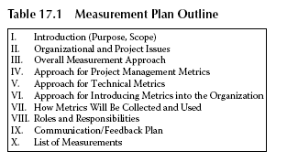

in the Measurement Plan needs to include your project’s and/or organization’s definition of each measure. Don’t assume that because you know what a “defect” is that everyone else has the same definition in mind. Be sure to keep your definition practical. Defining metrics is not an academic exercise.

Some Problems You May Encounter

The following is a list of problems we have encountered in metrics programs found in organizations. This list may be used as a checklist for any metrics or metrics programs you have implemented in your organization.

- Metrics are collected but not used
- No mechanism exists to distribute project performance metrics for review, comparison, and use Project-level metrics do not appear to be used to help project managers manage their projects
- No understanding of the value of metrics or how to use them is found No formal feedback loop found on the quality of the metrics, questions about them, and so forth
- Metrics reports are hard to review for trends Metrics data are inconsistent
- Personnel collect and input data that they think are right but are unsure
- A standard work breakdown structure (WBS) (a basic building block for management activities) is not followed consistently, and metrics cannot be traced back to WBS activities
- No one reviews the metrics data in the various databases for data integrity
- Training and communication are not occurring throughout the organization
- Procedures need to be devised to document metrics generation, collection, review, and use
- Existing procedures need to be updated to reflect changes
- Automated tools are not used, or the wrong automated tool is used, or the automated tool is used incorrectly The metrics reports are hard to read and understand
- Procedures are not well defined or consistently followed (usage of “may … if desired … at PM’s discretion”)
- The time it takes to identify, track, collect, and report the metrics is not measured
- Redundant data entry is rampant

Recommendations
Recommendations fall into two main categories:
1. Recommendations to improve the metrics identification and collection process itself
2. Recommendations to improve actual performance on projects

Recommendations to Improve the Metrics Identification and Collection Process Itself
The Number One, overall recommendation is to automate the process and make it seamless and simple! If it is too hard, the metrics collected will be useless. If it’s too damn hard, people won’t do it.
Other recommendations include:

- Involve your project managers and process owners with designing the metrics to be collected. Help them to understand why metrics are collected and how to use them to help run their projects.
- Collect metrics that the project managers need. Other metrics (i.e., corporate- level metrics used for executive reviews) can be generated automatically, based on the project-level data, and rolled up into a corporate report.
- Metrics should not be used punitively. They should be used to help assist the project managers in running their projects more effectively and to help improve estimating and tracking techniques.
- Facilitate workshops to derive meaningful metrics. Involve the project managers, directors, supervisors, metrics team, quality assurance personnel, process improvement specialists, technicians, budget and finance representatives, and any other interested individuals. Try to map your project-level and senior management-level metrics to business objectives and problems the organization faces.
- Provide feedback to the project managers and staff on the metrics collected so that they may see how they are doing compared to other projects in the organization and to other projects throughout the different business units.

Recommendations to Improve Actual Performance on Projects

Train the project managers and anyone else who generates, collects, reviews, or uses the metrics. First of all, make sure your PMs have received detailed, effective training in basic project management. Some managers simply do not have the skill sets required for the increasingly sophisticated tasks that their jobs require. For example, it is not uncommon to find PMs who are not really administrative-type managers concerned with costs and budgets. They more closely resemble technical leads. These PMs do not focus their energies on administrative tasks, such as documentation, planning, tracking, and reporting. They mostly concentrate on the technical fixes required for design and coding. Therefore, training on earned value—what it is, how to use it, how it can work for them—must be undertaken, as well as true training in how to do the job in your organization.
Metrics must be used. Instruct your staff (especially the PMs) in how the metrics can be used to help them manage their projects. Basically answer the question, “What’s in it for me?” Just mandating that the metrics be used and to follow the procedures, will not work.
Besides estimating, most projects seem to fumble when it comes to requirements.
Teams need to be formed to write instructions that are easy to read and understand, and on how to analyze and decompose requirements. The Standish Group, an organization devoted to collecting metrics summarizing performance of software organizations, has stated that up to 85 percent of all errors can be traced back to the Requirements phase. Therefore, most organizations can benefit from improving their requirements definition and analysis efforts, in that the Requirements phase appears to be where most errors are injected.

Summary

Generating metrics is not really that difficult—just look at the list we have presented! However, generating meaningful metrics that can be used in your organization is a little bit more complicated. Getting buy-in for the metrics effort will take some time and persuasion, and collecting and understanding the metrics will also present a challenge.
Do not give up! Most process improvement books (the CMMI among them) do not expect you to get it right the first time. In fact, the one thing that you will find is that, as you use the metrics, you will need to update them and make changes as your business needs change and as your staff becomes more knowledgeable.
Make sure you understand each metric selected for use, why it was selected, how it will be used, and how and when it will be collected. If not, ask. Maybe someone who generated the metrics decided that since these numbers worked at his
previous place of employment, they should work here. Or maybe the metrics were designed for some other department or type of work or level in the corporation that does not meet your needs.
There are many, many books on metrics and metrics programs available.
Although we make no recommendations, the ones most of our customers have used the most are:

Measuring the Software Process, William Florac and Anita Carleton, Addison
Wesley, 1999.
Practical Software Measurement, John McGarry, David Card, Cheryl Jones, Beth Layman, Elizabeth Clark, Joseph Dean, and Fred Hall, Addison Wesley, 2002.
Metrics and Models in Software Quality Engineering, Stephen Kan, Addison Wesley, 1995.
Understanding Variation: The Key to Managing Chaos, Donald J. Wheeler, SPC Press, 2000.

Chapter 19

A High-Maturity Perspective
This chapter discusses several concepts associated with high-maturity organizations and offers some suggestions on how to transition to a high-maturity organization.

We discuss how to create and use Process Performance Baselines and Process Performance Models. We define a high-maturity organization as an organization operating at CMMI Maturity Level 4 or Level 5 or Capability Level 4 or Level 5. While there are many high-maturity concepts we could tackle, we focus on those concepts that most people consider confusing.

The most fundamental high-maturity concept is how measurements are handled at high maturity. Measures in this chapter refer to both base measures and derived measures. Base measures are simple values of some attribute of interest; for example, the size of a document in pages or the effort to produce a document in hours. Derived measures are defined to be a function of two or more base measures.

An example of a derived measure is productivity. Productivity is a function of the size of a produced work product divided by the time to produce it (for example, design document productivity in pages per hour is the number of pages in the document divided by the hours to produce the document).

The high-maturity measurement concepts that we are going to cover are Process Performance Baselines, Process Performance Models, and Event Level Measurement.
Event level measures are used to build Process Performance Baselines. Process Performance Baselines are used to build Process Performance Models. The Process Performance Baselines and Process Performance Models rely on the predictable and stable processes that we described in our Chapter 18 on statistical process control.

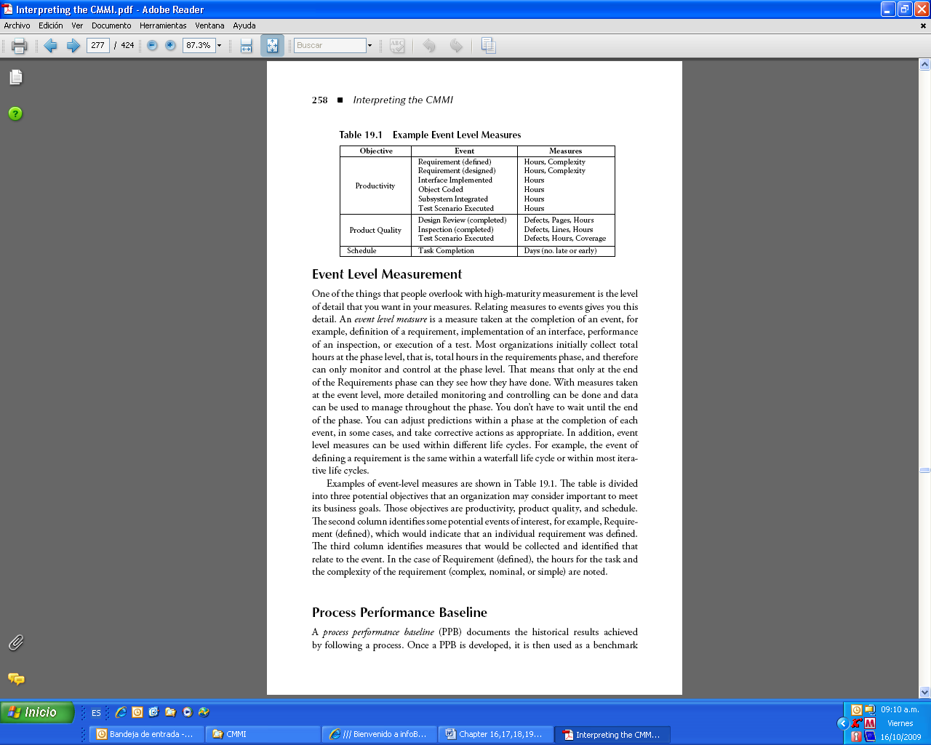

Event Level Measurement

One of the things that people overlook with high-maturity measurement is the level of detail that you want in your measures. Relating measures to events gives you this
detail. An event level measure is a measure taken at the completion of an event, for example, definition of a requirement, implementation of an interface, performance of an inspection, or execution of a test. Most organizations initially collect total hours at the phase level, that is, total hours in the requirements phase, and therefore
can only monitor and control at the phase level. That means that only at the end of the Requirements phase can they see how they have done. With measures taken at the event level, more detailed monitoring and controlling can be done and data can be used to manage throughout the phase. You don’t have to wait until the end of the phase. You can adjust predictions within a phase at the completion of each event, in some cases, and take corrective actions as appropriate. In addition, event level measures can be used within different life cycles. For example, the event of defining a requirement is the same within a waterfall life cycle or within most iterative life cycles.
Examples of event-level measures are shown in Table 19.1. The table is divided into three potential objectives that an organization may consider important to meet its business goals. Those objectives are productivity, product quality, and schedule.
The second column identifies some potential events of interest, for example, Requirement (defined), which would indicate that an individual requirement was defined.
The third column identifies measures that would be collected and identified that relate to the event. In the case of Requirement (defined), the hours for the task and the complexity of the requirement (complex, nominal, or simple) are noted.

Process Performance Baseline

A process performance baseline (PPB) documents the historical results achieved by following a process. Once a PPB is developed, it is then used as a benchmark for comparing actual process performance in a project against expected process performance.
Table 19.2 is an example of a PPB containing the historical productivity results from executing the process used for new development within an organization. There are PPB elements for each of the five phases that this organization has in its life cycle: Requirements Definition, Design, Implementation, Integration, and Systems Test. Implementation for the example organization includes both the classic code and unit test of a software system, plus implementation of individual nonsoftware components. The first line under Requirements Definition is the number of hours to define a complex requirement. There are elements for complex requirements, nominal requirements, and simple requirements with values for the upper limit, mean, and lower limit for each. The Design PPB elements are based on requirements and follow the same structure. Implementation, Integration, and Systems Test PPB elements are based on the work products most important to those phases.
In addition to productivity for new development, an organization would want to develop additional PPBs covering other processes, for example, productivity for maintenance. In addition to productivity, other important organizational goals (e.g., product quality and schedule) would be covered in separate PPBs.
This example PPB points out one of the most important issues with using measures, particularly with using measures at higher maturity levels—that is, the need for clear definitions of measures. In this case, what the organization means by a complex requirement, a nominal requirement, and a simple requirement must be clearly defined so that the people collecting the data can tell how to count them. Most
organizations start with a working definition and refine the definitions over time. In addition to defining what a requirement is, you also need to define what is included in the number of hours: Is it only hours sitting at your desk writing a requirement?
Does it include hours for attending status meetings to discuss your work? How do you count time for review of requirements? These are questions that need to be answered in your organization to ensure that the data are collected consistently.

So How Do You Use a PPB with Your Projects?

New projects could use the example PPB for estimating their effort based on estimates of the number of requirements, number of interfaces, number of design pages, and so on. The range of values (upper, mean, and lower) allows the estimators to determine the most likely, worst case, and best case estimates of not only productivity, but also the staffing levels that are needed.
We have personally witnessed the positive change in organizations when they have PPBs that people believe. The estimation and planning process becomes much more of a professional activity and less emotional. Project managers armed with PPBs based on historical process performance are less likely to fall victim to unfounded pressure to lower estimates and reduce schedules.

After planning, the PPB can also be used to monitor and control the project’s work by comparing the actual number of hours to perform the work against expected range of values for the PPB element. Remember, if the actual number of hours is outside the expected range, it is only meaningful if your process is already stable. Stabilizing your process takes time. Look for the cause, but don’t overreact.
Your process may have a lot of variation, and the tendency early on is to shoot the messenger. If people believe that bad things happen to people when the data are not what is expected, the people will find ways (devious and nefarious ways) to make the data acceptable. This is not what you want.

Process Performance Model

A closely related concept to the PPB is the Process Performance Model (PPM). The PPM describes the relationships among attributes of a process and its work products, and is used to estimate or predict a critical value that cannot be measured until later in the project’s life—for example, predicting the number of delivered defects or predicting the total effort. Attributes of a process include productivity, effort, defects produced, defects detected, and rework. Attributes of a product include size, stability, defects contained, response time, and mean time between failures. PPMs are built on historical data and are often built from PPBs. PPMs can be developed for a wide range of project objectives. Example PPMs include Reliability Models, Defect Models, and Productivity Models.
Table 19.3 is an example of a simple PPM for predicting effort based on both the PPB shown in Table 19.2 and organization historical effort distribution. The PPB elements at the top of the second column (Number of Complex Reqs, Number of Design Pages, Number of Components, etc.) come from the Unit of Measure column in Table 19.2. The Estimated Number of Elements column in Table 19.3

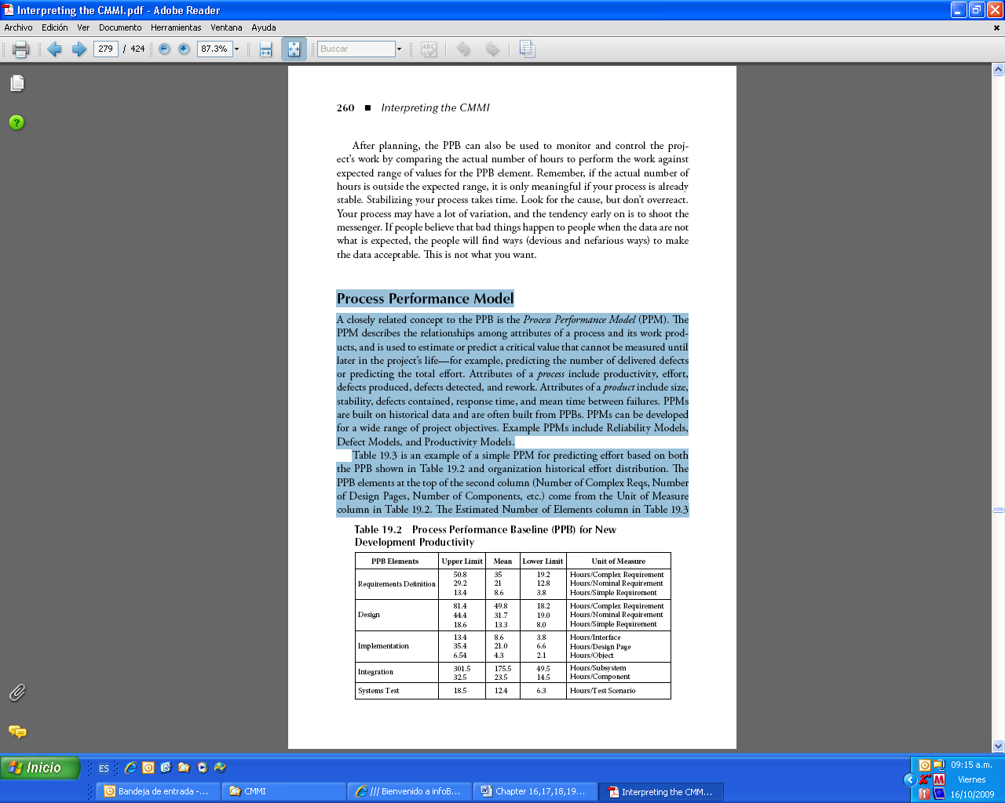

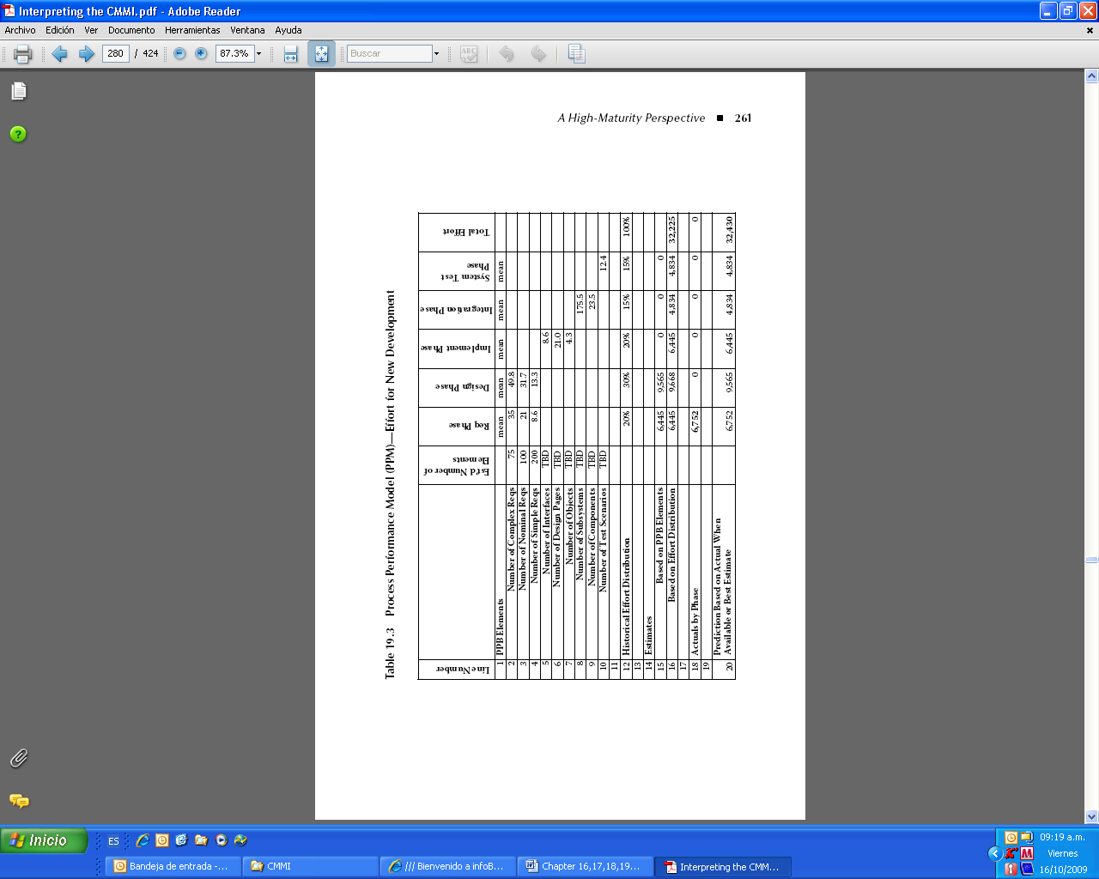

is derived from project information gathered and from the organization’s metrics database. The mean value for each PPB element by phase comes from the Mean column in Table 19.2. The Historical Effort Distribution on line 12 of Table 19.3 comes from project actuals stored in the organization’s metrics database.

The purpose of the example PPM for effort shown in Table 19.3 is to predict the total effort for the new development project. This model is designed to predict the total project effort throughout the life cycle, using more and better estimates and data as they become available. The example is divided into the following five sections.

PPB Elements (Lines 1–10)
For each of the elements, the model contains an estimated number of elements and the mean effort in hours for each applicable phase from the example PPB shown in Table 19.2. For example, line 2 shows that 75 complex requirements are estimated, that the mean number of effort hours in the Requirements phase for a complex requirement is 35, and that the mean number of effort hours in the Design
phase for a complex requirement is 49.8. At this time, only the number of complex, nominal, and simple requirement elements have been estimated; therefore, line 5 through line 10 show the remaining estimated number of elements as TBD (to be determined). Later in the project’s life cycle, as estimates for these other elements become available, they would be added to the model.

Historical Effort Distribution (Line 12)
This shows that, historically, projects have taken 20 percent of total staff effort in the Requirements phase, 30 percent in the Design phase, 20 percent in the Implementation phase, 15 percent in the Integration phase, and 15 percent in the Systems Test phase. (We have simplified the effort distribution percentages to make the example easier to follow.)

Estimates
The model has two estimates:
1. The first estimate on line 15 is based on the estimated number of PPB elements that most affect each phase. You can see how this is computed by looking at the value under the requirement phase. This value is computed by multiplying the estimated number of requirements by the mean number of effort hours for that type of requirement:
Number of complex reqs × mean effort req phase for complex reqs = 75 × 35 = 2,625 −



Actuals by Phase (Line 18)
This line captures the actual hours per phase. This example is shown at the completion of the requirements phase where 6,752 actual hours were used. No other actuals for this project are yet available.

Prediction Based on Actual When Available or Best Estimate (Line 20)
This is the real purpose of this model. The values on this line are selected from Actuals by Phase (line 18) if available. These are actuals for this project. If Actuals by Phase is not available, then the value from Estimate Based on PPB Element (line 15) is used, if available. Use the Estimate Based on Historical Effort Distribution (line 16) if no other values are available. The prediction is then 32,430, which is the sum of all phases. (Not to be confused with the Sum of All Fears, which is a book by Tom Clancy.)
So how do you use a PPM with your projects?
You use PPMs to estimate or predict a critical value that cannot be measured until later in the project’s life. Our example showed a model to predict total effort throughout the project life cycle. No one really knows what the total effort will be until the project is over.

We have seen a model similar to our example used to accurately predict total effort. The PPM used came within 5 percent of the total effort following the completion of the requirements phase. We have also seen models built that successfully predict number of delivered defects, mean time between failures, and number of system failures during integration testing. The exciting thing about the use of the models is that the focus of project management becomes trying to find defects and trying to accurately measure performance, and not on dysfunctional interoffice politics.
Not to confuse the issue, but Table 19.3 is a simplification of a PPM. The basic flaw in this model is that, by using the mean (or average) value of the historical data points, we disregard the distribution between the upper and lower levels of the phase. This means that if a project were to use this model to predict its effort throughout the life cycle, the project would most probably never hit the actual mean for each phase. Instead, the project effort would fall somewhere between the range of upper and lower limits. This is a problem that can be corrected by incorporating the upper and lower control limits into the model. The flaw in the model
could be corrected by producing a best case estimate and worst case estimate by substituting the upper limits or lower limits, respectively, for the mean value.

Transitioning to Level 4

Level 4, either capability level or maturity level, is about managing quantitatively.
It includes both organizational- and project-level quantitative management. When you read the CMMI, you realize that it is written from the perspective of an organization and its projects executing at a steady state. The Organizational Process Performance process area describes an organization that has in place both the PPBs and PPMs that will be useful to the projects. The Quantitative Project Management process area describes projects that have selected processes that will satisfy the project’s objectives, that are executing stable processes, and that are managing process performance to best satisfy the project’s quality and process–performance
objectives using PPBs and PPMs.
OK, so how do you transition to Level 4? Following are some steps that we recommend. You will most likely need to perform multiple iterations through these steps as you become more experienced and your data become better.

Select the Measures That Will Be the Basis for Your PPBs and PPMs

An organization needs to develop the PPBs and PPMs that will be used by the projects.
These baselines and models are built around what is important to the goals of the organization and the projects. We mentioned in earlier chapters that the only goals some organizations have are “to make money.” And so why is this a bad thing,you say? Well it’s not, but we need to decompose that goal into something that the engineering, product development, and support groups can directly contribute to.
Identify what the critical components and attributes are, and identify measures of the standard processes and their work products. Measures related to product quality, cost, and schedule are often your best bet.
In Chapter 17, “A Boatload of Metrics,” we identified a little over 200 measurements.
We are not advocating that you collect anywhere near that number for your baselines and models, but you can use that list as a resource.
An example of using a single measure to build a PPM occurred in an organization we worked with that was able to do some impressive forecasting work based on only one measurement (the number of defects expected per thousand lines of code based on a similar project). The organization used that single number, its project’s rate of defects found, and its project’s rate of defects closed over the last four weeks to build an initial prediction model of when they would finish testing.
They improved the model over the project’s life cycle and got real customer buy-in and support. The organization’s simple prediction model allowed them to better manage both the project schedule and customer expectations, turning a problem project into a success story. Before you ask, no—we are not saying this one success story makes the organization Level 4. But it did create an initial success that they were able to build upon and demonstrate the value of Quantitative Management to the organization.
Be sure to select measures that cover the life cycle for the types of projects that you want to quantitatively manage. For example, if you have maintenance projects, don’t just measure the development life cycle. You might measure the number of problem reports, time to review problem reports, time to implement problem reports, time to test, number of retests, and so forth.
You need to consider both breadth and depth. Breadth means the measures across the entire life cycle, for example, cost, schedule, defects, and effort; and depth means the details in areas that are critical to your organization, that is, number of
customer returns by release and number of subcontractor failures by vendor.

Collect the Measures Identified from the Projects

Often the hardest part of measurement is to get good data. Again don’t be disheartened if you find problems with the data. Even if your standard process requires that your projects collect certain metrics, you may find that the data are missing and/or incorrect. You may need to “mine the data”; this means dig them up. The data may be in lots of different forms—in paper records, Excel spreadsheets, Word documents, or PowerPoint slides. They may only be in project status reports. They may be in many separate systems in many separate departments—finance, engineering, human resources, and so forth. Don’t be surprised if you need to invest a lot of time and money to uncover old data.
Work with the projects early and often to make the data better. You may decide to take more time to collect new and better data.

Analyze the Data from the Projects

Chapter 18, “Statistical Process Control,” shows a number of tools that you can use to analyze the data. In some organizations, this will be the first time anyone outside the project has really looked closely at the data. You are most likely going to find missing data, incorrect or dirty data, and the data are likely to show that not all projects are really following the standard process. Your analysis activities should include the following steps:

1. Review and fix the data. Investigate and correct missing data, zeros (for things like number of hours to perform a task), really large or really small numbers.
2. Look for ways to normalize data across projects. For example, use “defects by size” not just “defects.”
3. Plot the data. Use a histogram to see if you have a normal or Poisson distribution.
Use a scatter diagram to see any correlations. Use a run chart to view any trends. Use control charts once you find data that show promise.
4. Investigate the out of control points for their root cause. It is best to get project team members involved with this analysis, since the recorded data are likely to be incomplete. Put corrective actions in place to address the root causes. (This is a good place to use the approach described in the Causal Analysis and Resolution process area.)

Establish Organizational PPBs and PPMs from the Project Data

Calculate the current and predicted process performance and capture that in a PPB.
Be sure to establish baselines that cover the life cycle for the types of projects that you want to quantitatively manage. You will most likely want baselines that cover cost, schedule, and product quality. Be sure to identify the profile of the projects used to create the baseline, for example, large development projects using a waterfall life cycle and formal peer reviews, medium development projects using iterative life cycle and informal peer reviews, or small maintenance projects using quality assurance-led reviews.
From the baselines, produce predictive models that will allow your projects to manage to the goals that are important to your organization. You will most likely want models that predict productivity, defect insertion and detection, and schedule.

Derive Project Goals
The steps up to now have been organizational, and while that may be important, we need to remember that, as defined by the CMMI, the projects within the organization produce and deliver the products and services.
So it is important to realize that the project has some goals to satisfy. These often include on-time delivery, implementing all the technical requirements of the project, and staying within cost and schedule. Goals may come from the customers.
Goals may also come from the organization—if you are reading this book, it is likely that the organization wants to improve or at least wants to get a rating. Those are organizational goals.
You need to derive the project goals so that you know what to quantitatively manage to get to those goals.

Select Critical Subprocesses to Be Managed by the Project

Ensure that you have a set of subprocesses that cover the life cycle (breadth) of the project, and ensure that the critical subprocesses go into enough detail (depth) on the things truly critical to your project.
Select the measures and define what needs to be done to collect and store the measures for the project. OK, here is where you may have a problem if the project
goals are not covered as part of your organizational goals. Investigate adding these project goals to the organizational goals, but only if appropriate. Some projects truly are unique. You may need to identify unique measures, baselines, and models to satisfy these project goals. However, we have found that most projects are not truly unique from other projects; therefore, the goals of the projects should have been incorporated into organizational goals.

Select the Process Performance Baselines to Be Used by the Project

You need to compare the profile of your project to the profile of projects used to create the baselines, and select a PPB or set of PPBs to use. OK, here is where you may have another problem if the projects used to create the PPB are nothing like your project. But, don’t give up just because things appear different. Here is an example:
We were working recently with a large enterprise with multiple groups around the United States. This company had been comparing the average number of hours to fix problem reports. It found maintenance data in three separate organizations of widely separated geographic locations, using different processes and separate collection activities. To its surprise, the values came back as 12 hours per problem report, 13 hours per problem report, and 15 hours per problem report. These organizations had not compared notes, yet they came within 20 percent of one another. While
you may want much closer ranges, these data proved useful in initial quantitative management of the maintenance projects.

Select the Process Performance Model(s) to be Used by the Project

Once you have selected the project’s goals, measures, subprocesses, and PPBs, you can select the PPMs to use on your project. These may include:

- Schedule and Cost Models
- Progress Models
- Reliability Models
- Defect Models (defect identification and removal rates, defect removal effectiveness, latent defect estimation)
- Productivity Models

You will need to calibrate the models to match your project’s performance. For example, your project will have its own defect and identification and removal rates that may be different from what is in the defect model. Be sure you understand the basis of the models before you do any calibration.

Manage the Project Quantitatively

The project can now use the PPBs and PPMs to manage process performance and to work toward achieving the organization’s and projects’ goals. This work includes:

- Maintaining control charts of the subprocesses and identifying the root cause of out of control points Adding the actual performance data to the prediction models
- Taking corrective actions throughout all phases of the project’s life cycle to best achieve the project’s quality and process–performance objectives

Start Early to Level 4
It takes some time for most organizations to collect the kind of data we have shown in the examples. If you don’t have this much data, don’t become disheartened. One of the things that we have found in working with organizations moving to high maturity is that even a little good data go a long way.

Transitioning to Level 5
The people we work with don’t have as much of a problem with the concepts at Level 5 as we have seen with Level 4. But there are a few points that need to be made with each of the process areas, that is, Organizational Innovation and Deployment (OID) and Causal Analysis and Resolution (CAR).
The OID process area contains a reasonable set of steps for a Level 5 process improvement function in the following seven specific practices as written:

SP 1.1 Collect and analyze process- and technology-improvement proposals.
SP 1.2 Identify and analyze innovative improvements that could increase the organization’s quality and process performance.
SP 1.3 Pilot process and technology improvements to select which ones to implement.
SP 1.4 Select process- and technology-improvements for deployment across the organization.
SP 2.1 Establish and maintain the plans for deploying the selected process and technology improvements.
SP 2.2 Manage the deployment of the selected process and technology improvements.
SP 2.3 Measure the effects of the deployed process and technology improvements.

A key to the OID process area that does not come out at the specific practice level is the assumption that the organization’s processes are quantitatively managed.
This is a key assumption since stable processes and quantitative data are the basis for several of the practices.
Following are some steps that we recommend for implementing OID in your organization.

Create an Organizational Group Responsible for the Collection of Improvement Suggestions
for Both Process and Technology
It is critical to the success of OID that you collect improvement proposals from across the organization and that these proposals are handled in a professional way.
Establishing a group responsible for reviewing improvement proposals is not an explicit CMMI requirement (the CMMI’s OID introductory notes refers to an infrastructure, not a group), but a responsible group is the only way we have seen
OID work. People need feedback on their proposals. We go into a lot of organizations where the staff has given up making suggestions because “nobody listens anyway.” You also need to make sure the group is not dysfunctional. We worked with one organization where the primary author of the organization’s standard process chaired the committee to review improvement suggestions. He saw all suggestions as a personal attack. The year after he was replaced as committee chair, the organization documented savings of over $700,000 from implementing process improvement proposals.

Establish a Well-Defined Process for Improvement Proposals

The process or procedures for improvement proposals need to include details on the improvement proposal content, the routing, the analysis, the reviewing, the initial approval of proposals, the feedback, the piloting methods, measurement methods, the review of piloting results, and final approval to roll out to the organization. The process or procedure should document the formats, the steps, and the authority. It should also identify the metrics to collect on the proposals, for example, number of proposals, how many from each group, time to respond, the number by status, and so forth. In addition, clear responsibility for independent process reviews and audits needs to be established to ensure the process is followed.
The analysis of improvement suggestions needs to be based on the data collected as part of the Level 4 activities. Use your PPBs and PPMs to calculate return on investment of the improvement proposals. To answer your question: no, we don’t believe you can do real OID before you do Level 4.
Be sure to estimate a return on investment before running any pilot of the improvement. Update these estimates as the understanding of the improvement increases. Record historical data on all estimates. The pilot procedures and plans need to include evaluation techniques, for example, walkthroughs, prototypes, and human simulations along with documented methods for measuring savings.

Establish Process Improvement Goals

Your organization should have improvement goals and manage to them. The organization needs to consider establishing three types of strategic process improvement goals:
1. Incremental Improvements
2. Innovative Improvement
3. Targeted Improvements
Incremental improvements are stepwise improvements accomplished by making the current processes and tools a little better. A source of incremental improvement opportunities can be found by analyzing the organization’s common defects from reviews and testing and other common causes of variation. The approach described in the Causal Analysis and Resolution process area works well for finding these kinds of improvements. These improvements are often the responsibility of the Process Improvement Group or a special team chartered to find incremental improvements.

Innovative improvements are major leaps in performance accomplished by bringing into the organization a significantly different process or technology. A good place to look for this type of improvement is from an external organization or specialists.
These improvements are often the responsibility of a Process Action Team chartered to address a particular area or problem.
Targeted improvements are specific areas that have been identified as problematic.
Senior management may establish an area of improvement as an organizational goal; for example, an organizational goal might be to reduce delivered defects by 20 percent. These goals are used to solicit improvement suggestions from across the organization.
The goal derivation, refinement, planning, and retirement process needs to be defined and understood by everyone involved in these activities. Be sure everyone participating is trained in goal derivation and process improvement including senior management. Consider establishing a Process Action Team(s) to create the process and create a draft set of goals. Use caution in defining the goals so that they don’t belittle individuals or disciplines.

Clearly Communicate Process Improvement Activities and Goals to the Staff

Senior management is responsible for clear and positive communication to the staff of the goals, why the goals are important, and their personal commitment to improvement. This can be a very positive activity for the organization, but only when senior management takes the lead and describes the positive reasons for improving the process and technology.
Goals need to be considered part of the project commitment process. Imposing annual organizational goals on ongoing, preexisting projects is a change in requirements that needs to be managed as any other requirements change. Don’t let your organization revert to Level 1 behavior by imposing uncommitted requirements on projects.
Remember to communicate seven times and three ways. The three ways might be the company Web page or newsletter, staff meetings, and “all hands” meetings.
We worked with one organization where the goal definition activity was not clearly communicated to the staff, and the rumor mill had decided that senior management was meeting with the project managers and technical leads in order to plan a massive layoff. The morale was turned around only after the chief technical officer called a special engineering-wide meeting to communicate what was really going on.
The other process area described in Maturity Level 5 is Causal Analysis and Resolution. The CAR process area is a high-level description of identifying causes of defects and other problems and taking action to prevent them from occurring.
The steps identified in the five specific practices are:

SP 1.1 Select the defects and other problems for analysis.
SP 1.2 Perform causal analysis of selected defects and other problems and propose actions to address them.
SP 2.1 Implement the selected action proposals that were developed in causal analysis.
SP 2.2 Evaluate the effect of changes on process performance.
SP 2.3 Record causal analysis and resolution data for use across the project and organization.
As we discussed in Chapter 8, “Understanding Maturity Level 5—Optimizing,” you can be doing these CAR activities much sooner than Level 5. However, from a high-maturity perspective, these activities become mandatory for a useful Level 5 implementation and very desirable for a successful Level 4.
When transitioning to Level 4, use the steps described as part of CAR to investigate special causes of variation for their root cause. As stated previously, it is best to get project team members involved with this analysis, since the recorded data are likely to be incomplete. Put corrective actions in place across the organization to address the root causes, as appropriate.
At Level 5, use the steps in CAR when looking for incremental improvements.
These steps can be the basis to investigate common causes of variation in your standard processes and technology usage, and to establish a plan to remove some of the undesirable common causes.
If you are looking for statistical techniques to use with CAR consider the run sheet, Pareto Chart, and Cause and Effect Diagram from our Statistical Process Control Chapter (Chapter 18).

Summary
This chapter describes our perspective and recommendations on high maturity. The high-maturity approaches described here take time and effort. We have seen the significant success that some organizations have with these approaches. We have also seen organizations attempt high-maturity behavior too soon before defining a solid set of organizational processes and working through the change management issues of Level 3. Those organizations have not been successful.
This chapter described both organizational and project-level high-maturity activities. We have a special word of caution here: be careful that in your organization you don’t build a wall between the projects and the organization. We have seen some companies where there is such a strong “we–they” approach to quantitative management that it has become dysfunctional. The projects point to the organizational group members building the baselines and models and say it is their fault we can’t do quality management because they have not given us what we need. And the organizational group members point to the projects and say it is their fault because we don’t have clean data. Don’t let this happen in your organization. Work from the beginning to establish organization-wide cooperation.
Transitioning to high maturity can be overwhelming. When in doubt, an organization should hire outside, expert help. This assistance is offered in the form of classes, mentoring, supervising data collection and reviews, and building models.
Of course, as consultants we support this approach. However, some organizations are loathe to hire consultants. The most important thing to remember about hiring consultants is that you can always fire consultants if you are not happy with them. So if you need help, get it.

